**Class Diagram**

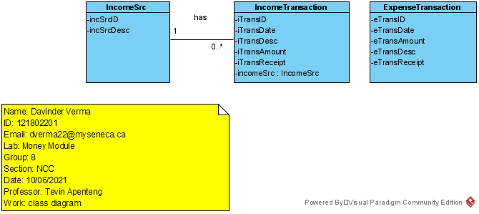

**User Story**

As the owner of this business, I would like to record my financial transactions so that I can quickly see how much money I’ve made and what I owe the government in HST. For my purposes, my expenses subtracted from my income.

Acceptance Criteria:

1. Must be able to query transactions by date and provide a total profit and total HST
2. Must be able to query transactions by date and by source of the income.
3. Differentiate between expenses and income – provide a running total of income – expenses
4. Calculate the HST owed to the government by subtracting HST paid on expenses from HST collected on income.

**Use Case Descriptions**

|  |  |  |  |
| --- | --- | --- | --- |
| **Use Case Name** | **Create an income transaction** | | |
| Triggering Event | Money coming into the business. | | |
| Brief Description | Allows the Owner to record an income transaction. | | |
| Actors | Owner | | |
| Related Use Cases |  | | |
| Preconditions | Owner has opened the Main Menu. | | |
| Post Conditions | Income transaction is saved and added to financial totals. | | |
| Flow of activities | Actor | | System |
|  |  | Requests to add a new income transaction | Displays a calendar  Prompts for description, transaction amount and HST amount  Displays a list of income sources and prompts for selection |
|  |  | Selects the transaction Date  Selects the income source  Enters the transaction description  Enters the transaction amount | Verifies that date is selected  Verifies that description and amount have been entered  Verifies that the income source was selected.  Calculates HST  Displays financial transaction  Prompts to save |
|  |  | Request to save | Saves the transaction and returns to the main menu |
| Exception Conditions | * Owner chooses to cancel adding the transaction | | |

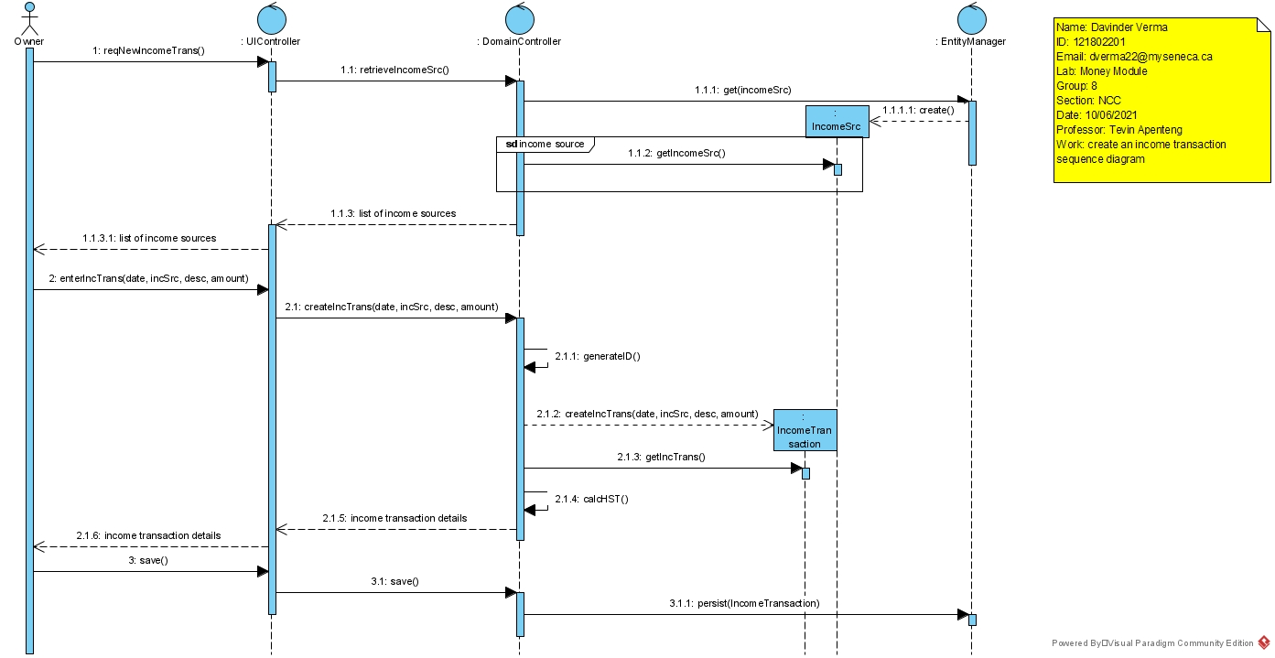

|  |  |  |  |
| --- | --- | --- | --- |
| **Use Case Name** | **Create an expense transaction** | | |
| Triggering Event | Money leaving the business. | | |
| Brief Description | Allows the Owner to record an expense transaction. | | |
| Actors | Owner | | |
| Related Use Cases |  | | |
| Preconditions | Owner has opened the Main Menu. | | |
| Post Conditions | Expense transaction is saved and added to financial totals. | | |
| Flow of activities | Actor | | System |
|  |  | Requests to add a new expense transaction | Displays a calendar  Prompts for description, transaction amount and HST amount |
|  |  | Selects the transaction Date  Enters the transaction description  Enters the transaction amount | Verifies that date is selected  Verifies that description and amount have been entered  Calculates HST  Displays financial transaction  Prompts to save |
|  |  | Request to save | Saves the transaction and returns to the main menu |
| Exception Conditions | * Owner chooses to cancel adding the transaction | | |

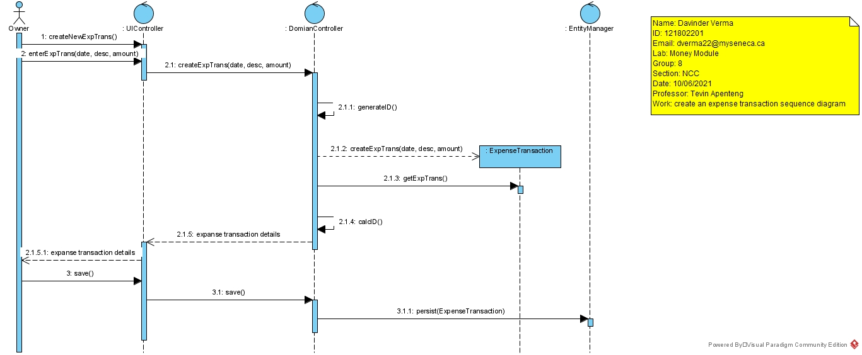

|  |  |  |  |
| --- | --- | --- | --- |
| **Use Case Name** | **Query Financial Transaction** | | |
| Triggering Event | Owner requires a list of transactions for a date period including Total Income, Total Expenses, Total Profit, Total HST collected, Total HST Paid, HST Owed | | |
| Brief Description | Allows the Owner to retrieve financial totals for a specified date range | | |
| Actors | Owner | | |
| Related Use Cases |  | | |
| Preconditions | Owner has opened the Main Menu. | | |
| Post Conditions | Financial transactions are retrieved, totaled and displayed | | |
| Flow of activities | Actor | | System |
|  | 1. | Requests to query financial transactions | Displays a calendar |
|  | 2. | Selects date range | Verifies that dates are selected  Retrieves transactions in the specified date range  Calculates and displays total income, total expenses, Profit, total HST Owed. Prompts to exit |
|  | 3. | Request to exit | returns to the main menu |
| Exception Conditions |  | | |
|  |  | | |

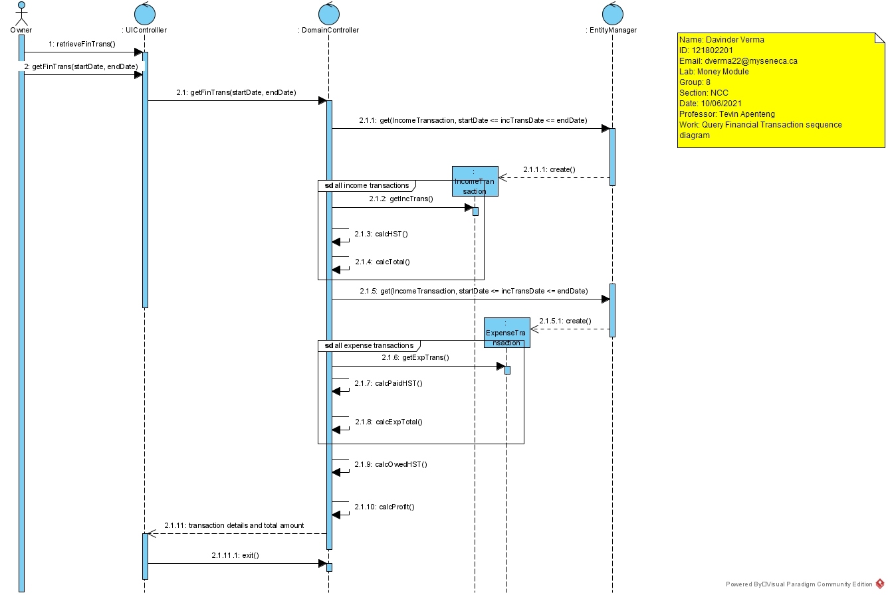

Your tasks:

1. Create a class diagram to support the above case study and Systems Use Case Specifications
2. Create an object level sequence diagram, detailing the Create Income Transaction systems use case specification
3. Create an object level sequence diagram, detailing the Create Income Transaction systems use case specification
4. Create an object level sequence diagram, detailing the Query Financial Transaction system use case specification.